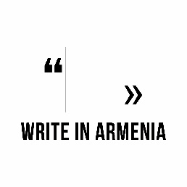 |  | 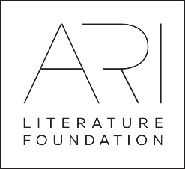
Application form (for Ukraine)

Applicant Information
Full Name:
 | Last | First
Date of birth
Gender: | Male ☐ | Female ☐
Address:
 | Street Address |  |  |  | Apartment/Unit #
 | City |  |  | ZIP Code | Country
Phone: |  | Email

Education
Institution:
Specialization:

From: |  | To: |  | Did you graduate? | YES  ☐ | NO  ☐ | Degree:

Current Employment, if any
Company/ Organization:
Position:

Blogs, websites, social media pages
You blog or website link:
Facebook page link:
Twitter page link:

Language skills

 | Fluent | Functional | Fair | Weak
English | ☐ | ☐ | ☐ | ☐
Other please add | ☐ | ☐ | ☐ | ☐
Other please add

Your writing
Current focus or theme in writing:
Preferred writing style or form:
Publications, if any
Where did you learn about the program

Notes:
The working language of the camp is English.
The program will cover travel expenses, lodging and meals for the whole period of the program. Program participants will be responsible for their own visa arrangements and expenses.
Requirements:
• 18-24 years old • Functionally fluent in English • Strong interest in writing as a future career

For Ukrainian writers: Please submit this application (in English), and the following documents:
- a cover letter explaining your interest in participating (in English),
- a cover letter explaining your interest in participating (in Ukrainian),
- your resume or CV (in English),
- your resume or CV (in Ukrainian),
- a writing sample (in Ukrainian; 250-500 words of fiction or 25-50 lines for poetry),
- a writing sample (in English; min 200 words of fiction or 20 lines of poetry)
to the both of the following addresses litlab@artarsenal.gov.ua and info@ariliterature.org by September 30, 2017.
Other notes:
- All applicants will be considered for the program without discrimination of race, color, religion, sex, sexual orientation, gender identity, national origin, or disability status.
- Please note that you will be placed in a room with a roommate. (Only same gender) roommates will be chosen by lottery drawing.
- If you have any special needs, physical restrictions, food restrictions, seasonal or other allergies or other conditions that program staff should be aware of please describe in the space below:

Project partners:

